1. AIM TO: Design DFA using simulator to accept the string the end with abc over set {a,b,c)

W= abbaababc

INPUT:

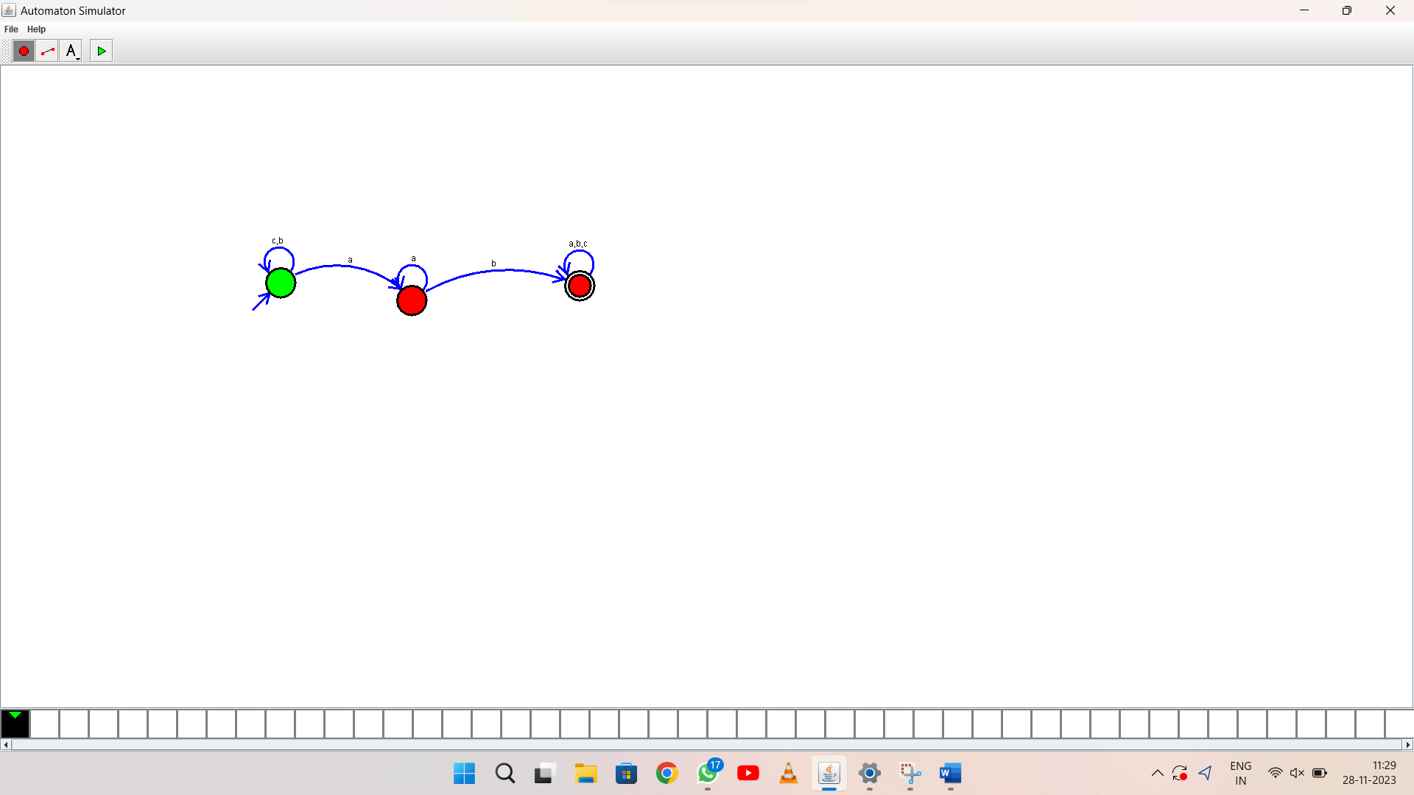

OUTPUT:

1. RESULT: thus Design DFA using simulator to accept the string the end with ab over set {a,b)

W= aaabab